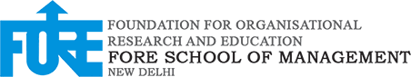

STREAMING DATA ANALYTICS – II

PROJECT REPORT

**End-to-End Streaming Analytics Solution for Railway Monitoring**

SUBMITTED TO: PROF. ADITYA DUA

SUBMITTED BY

Rupal Chaudhary (064041)

Siddhant Banyal (064050

**Introduction**

Railways play a vital role in modern transportation systems, facilitating the movement of people and goods across vast regions. Ensuring the safety, efficiency, and reliability of railway operations is of paramount importance. This project implements a real-time streaming analytics solution tailored to address the challenges faced by railway systems, such as operational inefficiencies, delays, and critical safety risks like collisions and fires.

The solution captures, processes, and analyzes streaming data from railway operations in real-time, enabling immediate responses to critical events. It leverages Apache Kafka for data ingestion, MongoDB for scalable storage, and Python for data processing and dynamic alert generation. Additionally, Grafana dashboards provide stakeholders with intuitive, real-time visualizations of key metrics, empowering better decision-making and proactive issue resolution.

The primary objectives of this project are as follows:

1. To develop a system capable of ingesting and processing railway data streams in real time.
2. To implement a dynamic alerting mechanism that triggers alerts based on specific conditions, such as collision risks or fire detection, with adjustable trigger points managed via UI or database configurations.
3. To build an interactive dashboard displaying critical metrics such as active alerts, their severity levels, and trends over time, thereby enhancing operational transparency and efficiency.

This project demonstrates how streaming analytics can transform railway operations by enabling rapid responses to critical events, improving safety standards, and ensuring timely resolution of maintenance issues. By addressing both immediate operational needs and long-term planning requirements, the system serves as a blueprint for leveraging streaming analytics in other transportation domains.

**System Architecture**

The architecture of the solution is designed to seamlessly integrate data ingestion, processing, storage, and visualization. Below is a detailed breakdown of the components:

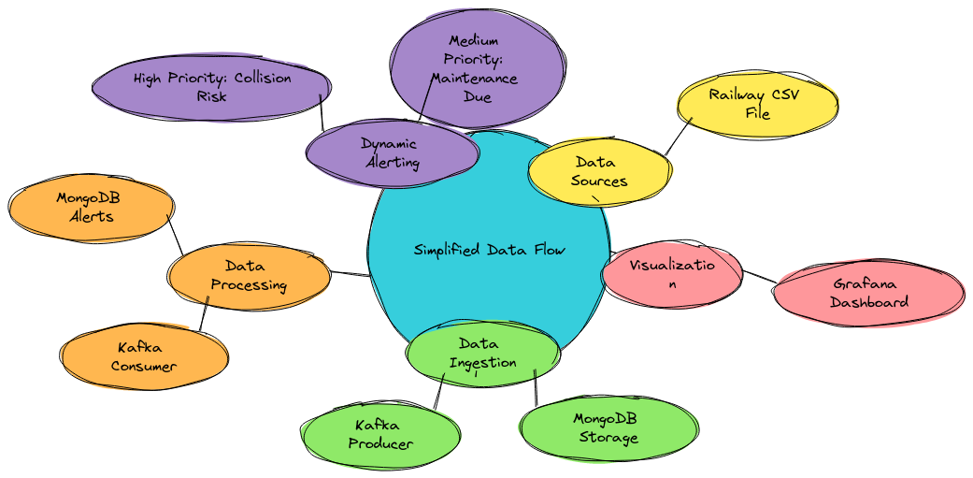

**1. Data Sources**

* Railway event data is simulated using a CSV file containing updates on train movements, alert types, and severity levels. This data represents real-world scenarios like collision risks, fire detection, and maintenance due.

**2. Data Ingestion**

* **Kafka Producer:** The producer reads data from the CSV file and publishes messages to a Kafka topic (stocktopic2) at regular intervals. Each message includes details such as time, train ID, station name, alert type, and severity.
* **Python Implementation:** The producer script (Railway_Producer.py) is designed to:
  + Read data from the CSV file.
  + Send data to Kafka.
  + Insert data into MongoDB for persistent storage.

**3. Data Processing**

* **Kafka Consumer:** The consumer subscribes to the Kafka topic and processes incoming messages. Key tasks include:
  + Parsing event data.
  + Triggering alerts based on alert type and severity.
  + Storing processed data in MongoDB for further analysis.
* **Python Implementation:** The consumer script (Railway_Consumer.py) handles the data processing logic and integrates with MongoDB.

**4. Data Storage**

* **MongoDB:** MongoDB serves as the central repository for storing railway event data. Collections are structured to store:
  + Event metadata (time, train ID, station).
  + Alert details (type, severity).

**5. Dynamic Alerting Mechanism**

* The consumer script dynamically triggers alerts based on event type and severity:
  + **Collision Risk:** Immediate high-priority alert.
  + **Fire Detection:** High-priority alert with severity-based messaging.
  + **Maintenance Due:** Medium-priority alert with a periodic notification.
* Alerts can be controlled and fine-tuned via a database or a user interface.

**6. Visualization**

* **Grafana Dashboard:** Real-time dashboards visualize key metrics, including:
  + Total active alerts.
  + Alert distribution by type and severity.
  + Trends over time for recurring issues.
* Dashboards provide stakeholders with actionable insights to mitigate risks and improve operations.

**Implementation**

**Kafka Producer**

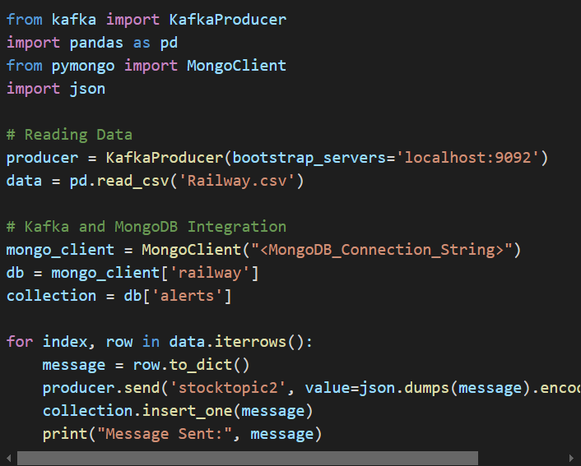

The producer script reads data from the CSV file (Railway.csv) and sends messages to the Kafka topic. MongoDB is used as a secondary storage for redundancy and future analytics. Key functions include:

* read_railway_from_csv: Loads data from the CSV file.
* send_to_kafka: Sends messages to Kafka.
* insert_into_mongo: Stores messages in MongoDB for persistence.

**Kafka Consumer**

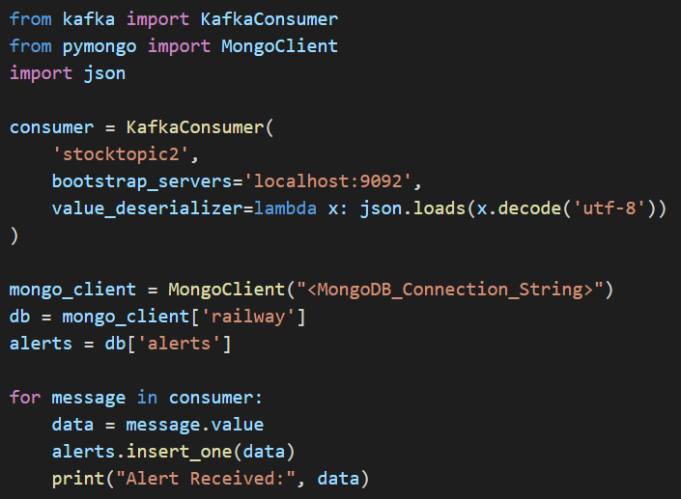

The consumer script subscribes to the Kafka topic and processes incoming messages. Key functions include:

* Parsing event data into structured formats.
* Storing data in MongoDB.
* Triggering alerts based on event type and severity.

**MongoDB**

MongoDB collections are structured to store:

* Event data for historical analysis.
* Alerts for real-time monitoring.

**Dashboard and Visualization**

The dashboard is a central feature of the railway monitoring system, designed to provide real-time insights into alerts, operational data, and trends. It helps stakeholders, such as railway operators and maintenance teams, monitor performance, identify issues, and take timely action.

**Purpose of the Dashboard**

The dashboard achieves the following:

1. **Real-Time Monitoring:** Displays live data streams for immediate action on alerts and events.
2. **Trend Analysis:** Highlights recurring issues over time to support planning and resource allocation.
3. **Decision Support:** Provides clear and actionable metrics for data-driven decision-making.

**Tools Used**

The dashboard uses **Grafana**, an open-source visualization tool known for its compatibility with various data sources like **MongoDB** and **Kafka**. Grafana’s interactive panels and customization options make it ideal for real-time monitoring.

**Key Panels and Metrics**

The Grafana dashboard in the provided images is designed to monitor railway operations and provide real-time insights into various alert types and severities. Here's a detailed analysis of the dashboard components based on the visualizations:

1. **Active Alerts Overview**
   * **Top Panels (Critical, High, Medium, Low Severity)**:
     + Displays a count of active alerts categorized by severity levels:

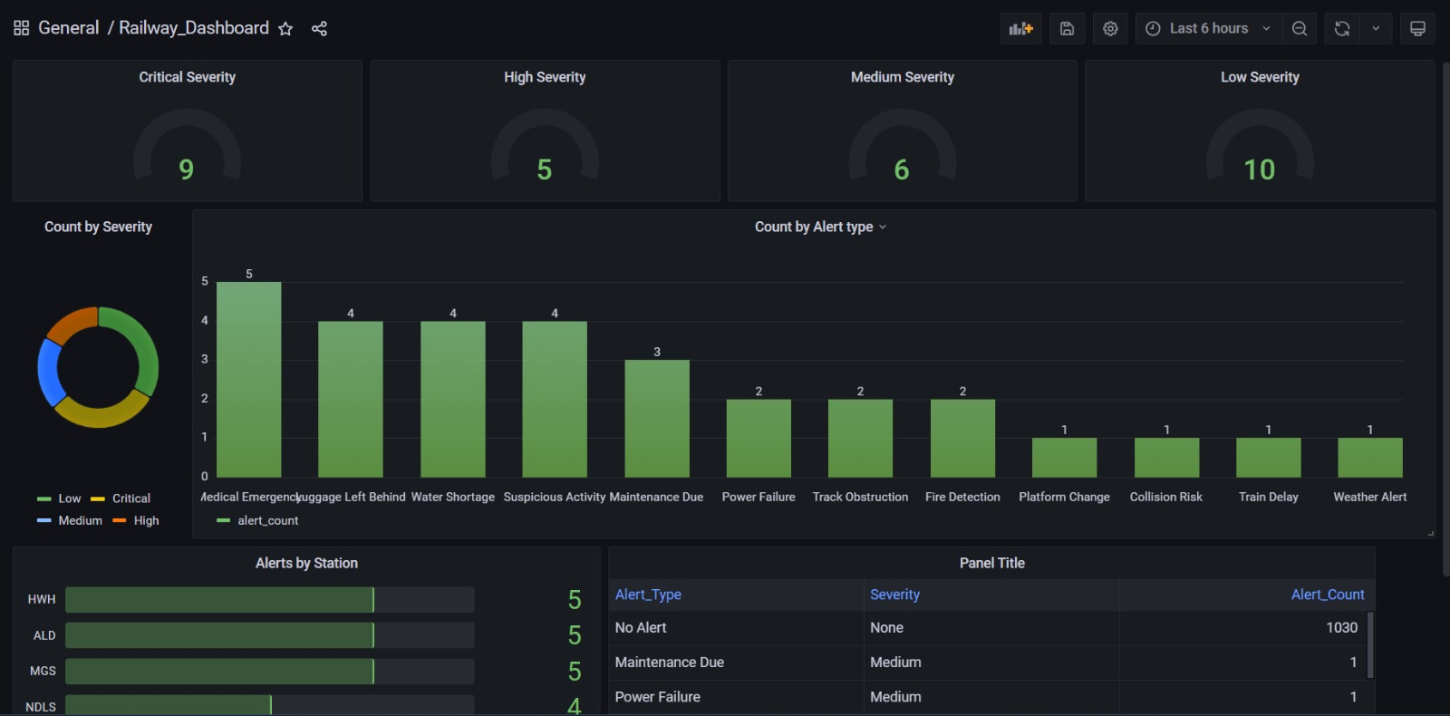

* + - * **Critical Severity**: 9 alerts.
      * **High Severity**: 5 alerts.
      * **Medium Severity**: 6 alerts.
      * **Low Severity**: 10 alerts.
    - Provides a quick summary for stakeholders to understand the current operational risk levels.

1. **Count by Severity (Bar Chart)**

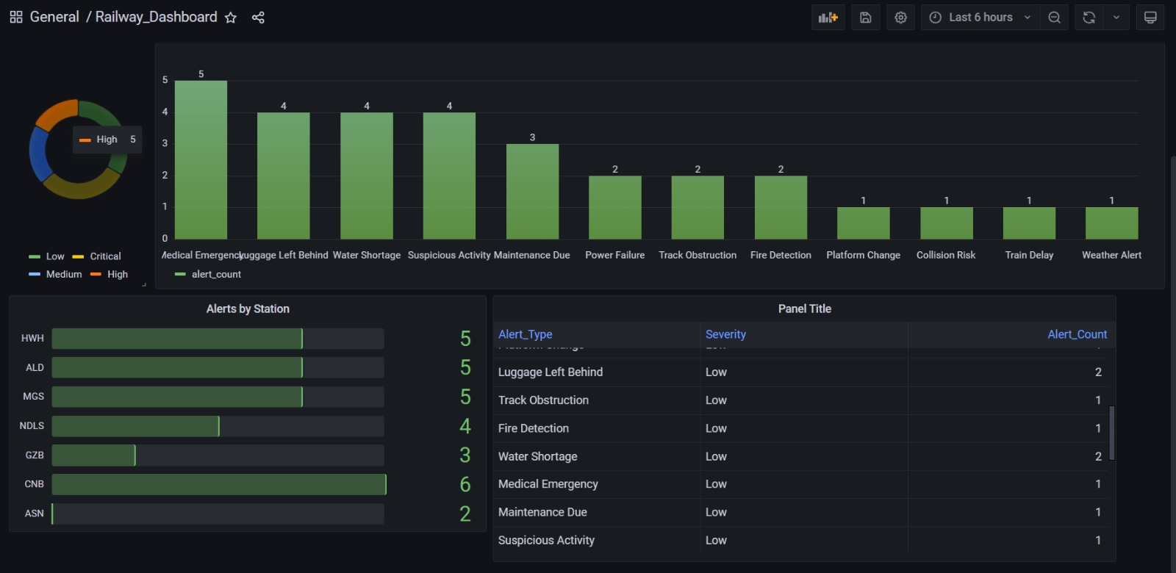

* + Represents alert counts based on their type and associated severity.
  + **Insight**:
    - The most frequent alert types are:
      * **Medical Emergency**: 5 instances.
      * **Luggage Left Behind**: 4 instances.
      * **Water Shortage**: 4 instances.
      * **Suspicious Activity**: 4 instances.
    - Less frequent but still notable issues include **Track Obstruction**, **Fire Detection**, **Platform Change**, etc.

1. **Severity Trends (Pie Chart)**
   * Illustrates the distribution of alerts by severity in percentage terms, providing a quick visual breakdown.



* + Color-coded for clarity:
    - Yellow: Low severity.
    - Red: Critical severity.
    - Blue: Medium severity.
    - Orange: High severity.

1. **Alerts by Station**
   * Horizontal bar chart detailing the number of alerts by railway station:
     + Stations such as **HWH (Howrah)**, **ALD (Allahabad)**, and **MGS (Mughalsarai)** report the highest number of alerts, with 5 each.
     + Other stations like **NDLS (New Delhi)** and **GZB (Ghaziabad)** follow with fewer alerts.



* + **Actionable Insight**: This helps prioritize stations requiring immediate attention.

1. **Detailed Alert Table**



* + Displays detailed information for each alert, including:
    - **Alert Type** (e.g., Maintenance Due, Power Failure).
    - **Severity** (e.g., Low, Medium).
    - **Alert Count**: Number of times the alert has occurred.
  + **Example**: Maintenance due and medical emergencies are common low-severity alerts.

**Usage and Impact**

1. **Real-Time Monitoring**:
   * Enables railway operators to track critical issues as they arise.
   * Supports decision-making for urgent interventions at stations with high alert counts.
2. **Severity Trends Analysis**:
   * Identifies patterns in alert severities, which can inform preventive maintenance and improve safety protocols.
3. **Geographic Mapping**:
   * Although geographic mapping isn't explicitly shown here, the station-specific data provides an indirect way to assess geographic trends and highlight areas requiring more robust infrastructure or operational improvements.
4. **Stakeholder Communication**:
   * This dashboard is a powerful tool for railway managers to present operational health to internal teams and external stakeholders.

**Example: Collision Risk Alert**

1. A "Collision Risk" alert for Train ID 12345 at Station ABC is triggered.
2. The **Active Alerts Panel** displays the new alert, and the **Geographic Mapping Panel** highlights Station ABC in red.
3. The **Severity Trends Panel** updates with the high-severity event.
4. Operators respond by activating emergency protocols and inspecting root causes using event logs

**Business Impact**

Implementing this solution provides the following benefits:

1. **Improved Safety:** Real-time alerts enable quick responses to emergencies, reducing risks.
2. **Operational Efficiency:** Proactive monitoring of maintenance schedules minimizes downtime.
3. **Data-Driven Decisions:** Insights from dashboards aid in resource allocation and strategic planning.

**Challenges and Limitations**

**Challenges**

* **Integration Issues:** Setting up Kafka and MongoDB required troubleshooting configuration errors.
* **Latency:** Delays in data processing under high traffic conditions.
* **Dashboard Customization:** Designing user-friendly and insightful visualizations.

**Limitations**

* **Scalability:** Current setup handles limited data volume; scaling requires infrastructure upgrades.
* **Real-Time Processing:** High latency in alerting for specific scenarios.

**Future Enhancements**

This project demonstrates a robust real-time streaming analytics solution for railway monitoring. The integration of Kafka, MongoDB, and Grafana provides a scalable and efficient framework for data-driven decision-making. Future enhancements could include:

1. **Predictive Analytics:** Integrate machine learning to forecast issues and optimize maintenance schedules.
2. **Mobile Support:** Develop mobile dashboards for on-the-go monitoring.
3. **Custom Alerts:** Allow users to define thresholds for alert triggers.
4. **Machine Learning Integration:** Predictive models for proactive maintenance.
5. **Scalability Improvements:** Deploying the solution on distributed cloud platforms.
6. **Enhanced Visualization:** Adding more detailed metrics and user interaction capabilities.